Table of Contents:
LIMITS OF JUDICIAL INTERVENTION VIA CURATIVE PETITIONS: CAN COURTS RE-ENTER THE MERITS ON PATENT ILLEGALITY?
…Page No. 2
CLAIMS FOR MORTGAGE ENFORCEMENT AND DECLARATORY RELIEFS NOT AMENABLE TO ARBITRATION
…Page No. 5
ONE PARTNER, NO FREE PASS – ARBITRATION CANNOT BE INVOKED WITHOUT AUTHORITY OF ALL THE PARTNERS
…Page No. 8
DELAY HAS CONSEQUENCES – COURTS MUST SCRUTINIZE LONG DELAYS BEFORE REVIVING DORMANT APPEALS
…Page No. 11
WHEN ONE CLAUSE BINDS THEM ALL: ARBITRATION AGREEMENTS AND PURCHASE ORDERS UNDER A MASTER CONTRACT
…Page No. 14
COUNTER-CLAIMS IN ARBITRATION: LIMITATION PERIOD AND RISK OF PARALLEL PROCEEDINGS …Page No. 17
WIELDING THE SWORD OF DAMOCLES: ARBITRAL TRIBUNAL'S POWER TO TERMINATE PROCEEDINGS FOR NON-PAYMENT OF FEES
…Page No. 20
SCOPE OF REFERENCE UNDER SECTION 11 ONLY DETERMINES PRIMA FACIE VALIDITY OF ARBITRATION AGREEMENT OR DOES IT GO BEYOND
…Page No. 22
ALLEGATIONS OF FRAUD DO NOT AUTOMATICALLY RENDER A DISPUTE NON-ARBITRABLE; A DISTINCTION EXISTS BETWEEN SERIOUS FRAUD AND FRAUD SIMPLICITER.
…Page No. 25
JUDICIAL CLARIFICATION ON INSUFFICIENT STAMPING: AFFIRMING CURABILITY IN ARBITRATION AGREEMENT
…Page No. 28
____________________________________

LIMITS OF JUDICIAL INTERVENTION VIA CURATIVE PETITIONS: CAN COURTS RE-ENTER THE MERITS ON PATENT ILLEGALITY? 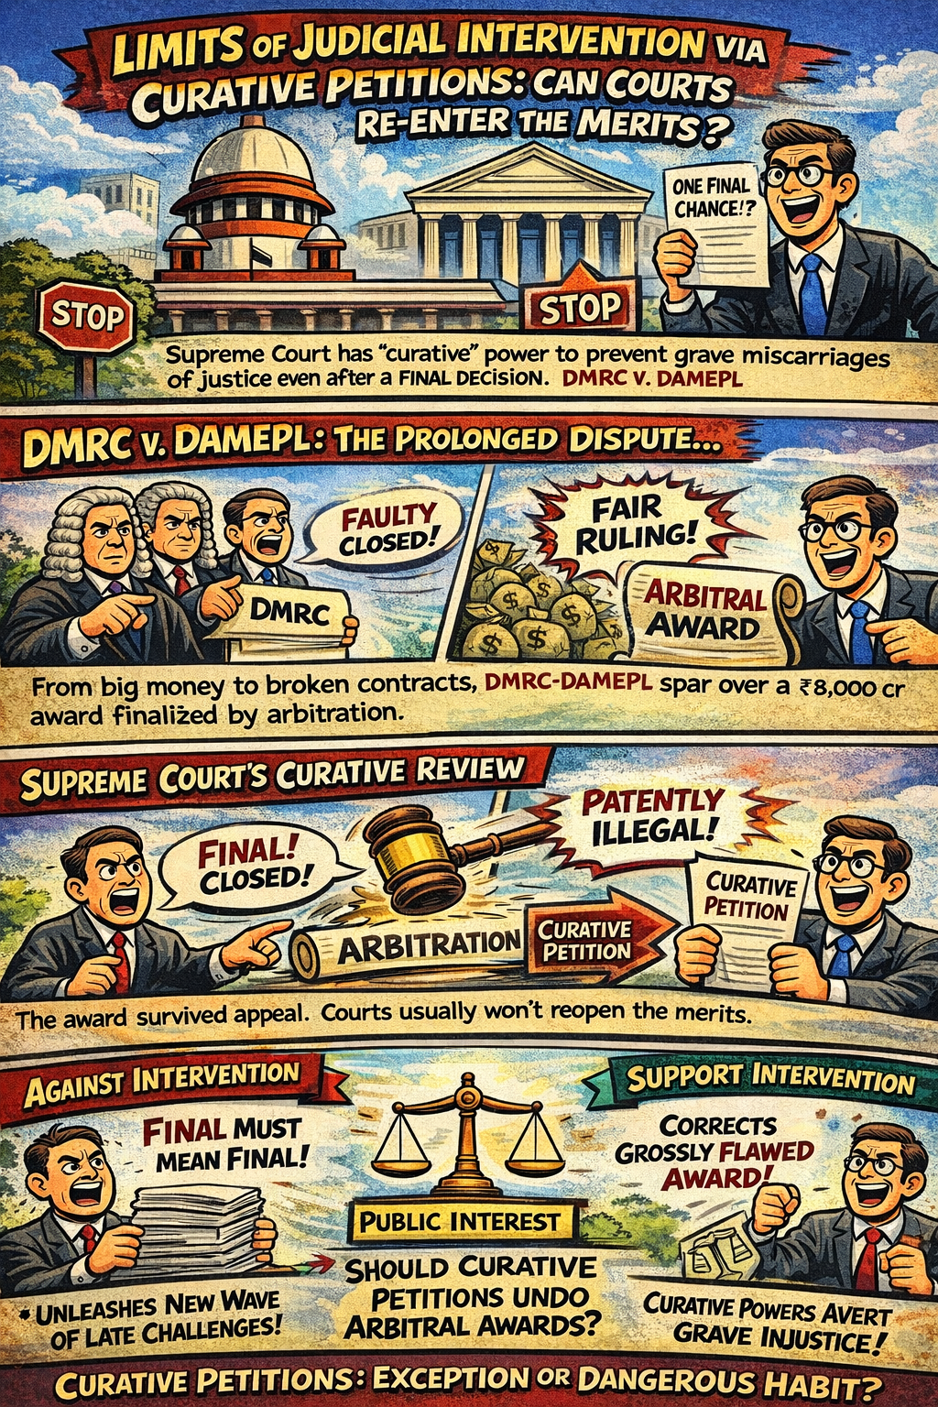
- Introduction
Arbitration law in India is founded on the principles of finality, minimal judicial interference, and party autonomy. The Arbitration and Conciliation Act, 1996 envisages limited court supervision, confining judicial review of arbitral awards to narrowly defined grounds.
However, the Supreme Court’s decision in Delhi Metro Rail Corporation Limited v. Delhi Airport Metro Express Private Limited (DMRC-DAMPEL) has reignited debate on whether courts can revisit the merits of arbitral awards through curative petitions, particularly on the ground of “patent illegality.” This ruling raises important questions regarding the permissible limits of judicial intervention and the certainty of arbitration outcomes.
- The DMRC–DAMEPL Dispute: A Prolonged Legal Journey
The dispute arose from a concession agreement for the Delhi Airport Metro Express Line. After operational and safety concerns were raised, arbitration was invoked, culminating in a substantial monetary award in favour of Delhi Airport Metro Express Private Limited.
This award survived scrutiny under Section 34 of the Arbitration Act but was set aside by the Division Bench of the Delhi High Court under Section 37 on grounds of patent illegality. Subsequently, the Supreme Court restored the award under Article 136.
Years later, invoking its curative jurisdiction under Articles 137 and 142 of the Constitution, the Supreme Court reversed its own earlier decision, finally setting aside the arbitral award. The litigation spanned over a decade, raising serious concerns about delay and finality in commercial dispute resolution.
- Critique: Expansion of Judicial Review Through Curative Petitions
Critics argue that the Supreme Court’s intervention stretches the curative jurisdiction beyond its intended limits. As settled in Rupa Ashok Hurra v. Ashok Hurra, curative petitions are meant to be entertained only in exceptional circumstances involving gross miscarriage of justice.
In the DMRC case, the Court undertook a detailed re-evaluation of the arbitral award on merits, applying the test of patent illegality under Section 34(2A), a scrutiny ordinarily barred at the curative stage. This approach risks transforming curative petitions into an additional appellate layer, especially in high-value disputes involving the State.
Such expansion may undermine the pro-arbitration policy and discourage private participation in public contracts due to uncertainty and prolonged litigation.
- Justification and Implications for Arbitration Law
On the other hand, proponents view the decision as a necessary correction of judicial error. The Court relied on principles laid down in Associate Builders v. Delhi Development Authority and Ssangyong Engineering and Construction Private Limited v. National Highways Authority of India, holding that awards which are perverse or ignore vital evidence warrant intervention.
The judgment is defended as a safeguard against irrational awards that burden public utilities and compromise public interest. Importantly, the Court clarified that such curative intervention is not to become routine, thereby reaffirming that arbitration awards should ordinarily attain finality after Section 37 review
- Conclusion
The decision in Delhi Metro Rail Corporation Limited v. Delhi Airport Metro Express Private Limited marks a pivotal moment in Indian arbitration jurisprudence. While it underscores the Supreme Court’s power to prevent grave injustice, it simultaneously exposes tensions between judicial correction and arbitral finality. The ruling highlights the need for clearer doctrinal limits on patent illegality and curative jurisdiction to ensure arbitration remains an efficient and reliable dispute resolution mechanism rather than an extension of protracted litigation.

CLAIMS FOR MORTGAGE ENFORCEMENT AND DECLARATORY RELIEFS NOT AMENABLE TO ARBITRATION

- Introduction
Arbitration, long regarded as an alternative, has firmly established itself as the principal method for settling claims arising from voracious or complex contracts. This preference is deeply rooted in public policy: it ensures the efficient use of judicial resources by offloading voluminous contractual claims, which might otherwise languish in overburdened courts. Critically, the resultant arbitral award acts as a judgment in personam, binding only the parties to the dispute, thereby justifying its status as a forensically sound, party-centric mode of dispute resolution. However, in certain kinds of suits, it still remains to be seen whether the claims in themselves are arbitrable.
- Suits pertaining to Foreclosures and Redemption
In cases of suits relating to foreclosure, and on the flipside, suits for redemption- it is often not the case that the interests over the property stays constrained between the mortgagor and the mortgagee. When the interests potentially could cascade over to, say- puisne/mesne mortgagees, persons entitled to the equity of redemption, persons having an interest in the mortgaged property, auction-purchasers and persons in possession, then the arbitrability of the disputes is in itself resting on a conjecture. The legal phenomenon represented by this bundle of interests in suits relating to mortgage is comprehensively governed by Order XXXIV of the Code of Civil Procedure, 1908 (CPC). The entire Order and its attendant Rules prescribe the detailed procedural framework for adjudicating various mortgage suits before the civil courts. Furthermore, it meticulously outlines the process involving the necessary parties to a mortgage suit, as well as the procedure for passing preliminary and final decrees in suits concerning foreclosure, redemption, sale, and the realization of any balance amounts. Since this Order establishes a class of actions in rem, the suits contemplated would be manifestly incompatible with the principles of arbitrability.

Besides the foregoing predicament to arbitrability, there also exists the reason of legislative aim and objective behind having specific disputes falling under the jurisdiction of special fora. In this regard, it is necessary to examine the objective of the Recovery of Debts Due to Banks and Financial Institutions Act, 1993 (‘DRT Act’). The DRT Act was legislated with the foremost objective of expediting the adjudication and recovery of debts owed to banks and financial institutions; and it provides for mutually complementary remedy with the condition precedent that process for adjudication has to be instituted. The Apex Court has time and again reiterated that the disputes falling under the jurisdiction of special fora, as a matter of public policy, could not be considered as ‘arbitrable dovetails’.

- Conclusion
Hence, claims for mortgage enforcement and declaratory reliefs, in so far as, are governed by Order XXXIV CPC inherently conflict with arbitrability. Their nature as actions in rem affects third-party interests (like mesne mortgagees and auction-purchasers), exceeding the in personam scope of arbitration. Furthermore, public policy, as evidenced by special statutes like the DRT Act, mandates that debt recovery and claims involving complex property rights be settled through specialized, statutory adjudication. This dual constraint, the in-rem character and explicit legislative intent firmly exclude these disputes from the arbitral domain.

ONE PARTNER, NO FREE PASS – ARBITRATION CANNOT BE INVOKED WITHOUT AUTHORITY OF ALL THE PARTNERS

- Background
Kerala High Court recently examined an important question under arbitration law:
Can a single partner of a partnership firm invoke arbitration without the consent of the other partners?
The dispute arose between M/s P K Chandrasekharan Nair & Co., a partnership firm, and Hindustan Petroleum Corporation Limited (HPCL). The firm was operating a retail petroleum outlet under an agreement executed in 1970, which was periodically renewed until 2019. The firm consisted of two partners.
- Events Leading to the Dispute
In 2013, the landowner of the property where the outlet operated filed a suit for recovery of possession. The suit was eventually dismissed, and the dispute between the landowner and HPCL was referred to arbitration under a lease deed. However, the fallout was significant. The landowner refused to renew the lease and did not consent to renewal of the explosive license. As a result, the retail outlet was shut down in 2021.
In 2022, HPCL asked the firm to locate an alternate site due to pending litigation. Subsequently, HPCL permitted another dealer to operate a new retail outlet at the same premises. Claiming that the firm was entitled to operate the outlet until 30/06/2029, one partner issued a legal notice seeking INR 2.51 crores as damages. When no response was received, arbitration was invoked under the agreement.
- Judicial Journey and Contentions
Petitioner’s Stand: The petitioner argued that the scope of inquiry under Section 11 of the Arbitration and Conciliation Act, 1996 is narrow. According to him, the Court only needs to verify the existence of a valid arbitration agreement. Questions of authority, merits, or arbitrability, he contended, must be left to the arbitrator.

Respondent’s Stand: HPCL objected to the maintainability of the arbitration request. It was argued that no express authority had been given by the other partner to invoke arbitration. Reliance was placed on Section 19(2)(a) of the Indian Partnership Act, 1932, which clearly states that a partner has no implied authority to submit firm disputes to Arbitration.
- Court’s Analysis
The Hon’ble Court carefully examined the scope of Section 11 proceedings. The Court acknowledged the Supreme Court’s ruling in In Re: Interplay between Arbitration Agreements and the Indian Stamp Act (2024), which limited Section 11 scrutiny to the existence and formal validity of an arbitration agreement.
However, the Court made an important distinction. The issue here was not the existence of the arbitration clause, but whether the application itself was maintainable.

The Court clarified that:
- Appointment of an arbitrator under Section 11 is a special judicial power.
- It cannot be exercised mechanically.
- Primary scrutiny of maintainability lies squarely with the Court.

- Verdict
The Hon’ble Kerala High Court held the following:
- A single partner cannot invoke arbitration on behalf of the firm without express authority or consent from the other partners.
- Allowing such unilateral invocation may result in an arbitral award that does not bind the firm or the remaining partners.
- The arbitration request was therefore not maintainable.
Accordingly, the Section 11 Application was dismissed.
- Conclusion and Implication
This order carries important inferences:
- Arbitration clauses in partnership agreements do not operate in isolation from partnership law.
- Firms must ensure clear authorization before initiating arbitration.
- Courts will scrutinize maintainability and authority at the Section 11 stage itself.
- The judgment promotes certainty and protects non-consenting partners from being bound by unilateral actions.
Thus, the Hon’ble Kerala High Court reaffirmed that arbitration, while party-driven, cannot bypass statutory safeguards under partnership law.

DELAY HAS CONSEQUENCES – COURTS MUST SCRUTINIZE LONG DELAYS BEFORE REVIVING DORMANT APPEALS

- Background
In a significant ruling on procedural discipline and delay condonation, the Supreme Court in Sethia Infrastructure Pvt. Ltd. v. Mafatlal Mangilal Kothari & Ors. set aside an order of the High Court which had condoned an extraordinary delay of 5,250 days in restoring a first appeal dismissed for non-prosecution. This judgment underscores an important principle that the courts cannot revive long-dormant proceedings mechanically, especially when rights may have crystallized during the interregnum.
- Origin of the Dispute
The litigation traces its roots to a suit for eviction filed by the respondents. The suit was dismissed by the Trial Court on 07/07/1988. Aggrieved, the plaintiffs preferred a first appeal, which was admitted in 1989.
The appeal remained pending for nearly two decades. On 20/02/2008, the Hon’ble High Court passed a conditional order. It directed the appellants to file a compilation of pleadings within three months. It further clarified that failure to comply would result in the appeal being deemed dismissed for non-prosecution, without further reference to the Court. The condition was not complied with. Consequently, the appeal stood dismissed in May 2008.
- Judicial Journey?
After the dismissal, the appeal remained dormant for over 14 years. In 2022, the original appellants filed an application seeking:
- Restoration of the appeal, and
- Condonation of a delay of 5,250 days.
By an order dated 25/10/2023, the Hon’ble High Court condoned the delay and restored the appeal. The order was passed in the absence of the non-applicants, merely recording that private service had been completed and relying on a prior Supreme Court judgment. Aggrieved by this restoration, Sethia Infrastructure Pvt. Ltd., which had stepped in as a developer during the period of dismissal, approached the Hon’ble Supreme Court.
- Key Contentions
Appellant’s Stand: The appellant argued that condoning such an inordinate delay without reasons was arbitrary and legally unsustainable. It was submitted that third-party rights had arisen during the long period when the appeal stood dismissed. The Hon’ble High Court, it was contended, failed to consider the serious prejudice caused to parties who had acted on the finality of the dismissal.
Respondent’s Stand: The Respondent supported the restoration, relying on judicial precedents allowing liberal condonation of delay in interest of justice.
- Analysis by the Supreme Court
The Hon’ble Supreme Court expressed serious concern over the manner in which the delay had been condoned. The Court observed that when an application for restoration is filed after a huge lapse of time, the Court must remain conscious of certain realities:
- Time does not stand still;
- Rights may crystallize in favour of third parties;
- New stakeholders may enter the scene;
- Long silence may be strategic, rather than accidental.

The Hon’ble Supreme Court noted that the High Court’s order assigned no reasons for condoning a delay of 5,250 days. Furthermore, it failed to consider the possibility of third-party rights and was passed without hearing the developer who had commenced construction on a large scale.

The Hon’ble Supreme Court also remarked, prima facie, that the Respondents appeared to have “woken up from their alleged slumber” only after a developer had entered the property and commenced development.
- Verdict
The Hon’ble Supreme Court held that the impugned order could not be legally sustained. In view thereof, it set aside the High Court’s order condoning the delay and restoring the appeal. The matter was remitted back to the High Court for fresh consideration. The Hon’ble Supreme Court further directed that the Application for condonation of delay be decided after hearing the appellant/developer. Finally, it observed that that, if necessary, the developer may be impleaded as a party. In view of the above, the parties were directed to appear before the Hon’ble High Court on 02/09/2025.
- Conclusion and Implications
This judgment sends a clear message on procedural accountability:
- Condonation of delay is not automatic, especially when the delay is extreme.
- Courts must give reasoned orders while exercising discretion.
- Restoration of old matters can seriously impact third-party rights.
- Finality in litigation cannot be lightly unsettled.
The aforesaid ruling balances access to justice with certainty and fairness in civil proceedings. The Hon’ble Supreme Court reaffirmed that while courts may adopt a liberal approach to condonation of delay, such liberality has limits. Extraordinary delays demand extraordinary justification. Absent careful scrutiny, revival of stale proceedings risks undermining legal certainty and legitimate expectations built over time.

WHEN ONE CLAUSE BINDS THEM ALL: ARBITRATION AGREEMENTS AND PURCHASE ORDERS UNDER A MASTER CONTRACT
Did You Know?
Even if a purchase order does not mention arbitration at all, parties may still be required to arbitrate simply because the master contract contains an arbitration clause.
  - Introduction
In commercial transactions, parties often execute a master contract setting out the overarching terms while issuing multiple purchase orders (“POs”) to operationalize individual supplies. A recurring question in both litigation and arbitration is whether these Pos many of which are brief, operational documents, are bound by the arbitration clause in the parent agreement. The issue has practical significance: jurisdictional objections, appointment of arbitrators, and maintainability of claims frequently turn on whether the PO incorporates the arbitration agreement. This article analyses the legal position under Indian law, focusing on statutory requirements and key decisions
  - Legal Framework
The starting point is Section 7 of the Arbitration and Conciliation Act 1996, which sets out the requirements for a valid arbitration agreement, including the need for written evidence of consent. Incorporation by reference is recognized under Section 7(5), enabling an arbitration clause in one document to apply to another if the latter “makes a reference” to the former. Courts therefore examine whether the PO and master contract form part of a composite transaction, whether the PO expressly or implicitly adopts the terms of the parent document, and whether the conduct of parties suggests an intention to be bound. In practice, POs rarely function as standalone contracts; instead, they operationalize a larger commercial understanding.
  - Key Judicial Developments
In M.R. Engineers & Contractors v Som Datt Builders (2009), the Supreme Court held that incorporation of an arbitration clause requires a conscious acceptance of that clause, not merely a general reference to another document.
The Court refined this in Inox Wind Ltd v Thermocables Ltd (2018), where the POs explicitly referred to the master contract. The Court held that such reference was sufficient to import the arbitration clause into the PO, especially because the parties had acted on the contractual structure without objection.
In Bharat Broadband Network Ltd v United Telecoms Ltd (2019), the Court reiterated that intention remains paramount and mere silence in a PO is not fatal if the PO derives meaning and validity from the master contract.
More recently, in DLF Home Developers Ltd v Rajapura Homes (2021), the Court affirmed that multiple contemporaneous documents forming a single commercial relationship must be read together. Where transactions are intertwined, arbitration clauses in principal documents may extend to subsidiary instruments.
  - Analysis and Practical Implications
For litigators, these decisions highlight that jurisdictional objections based on the absence of an arbitration clause in a PO are increasingly unlikely to succeed when the PO expressly cross-refers to, or is inextricably linked with, the master contract.
For students, these cases demonstrate the importance of contractual integration and the doctrine of incorporation by reference. A PO will generally be bound by the arbitration clause when: (i) it refers to the master contract; (ii) it forms part of a continuous relationship; or (iii) parties have consistently acted under a unified contractual framework. Conversely, if a PO is drafted as an independent contract with terms conflicting with the master agreement, courts may hesitate to import the arbitration clause.
  - Conclusion
Indian jurisprudence increasingly supports extending arbitration clauses in master contracts to POs that operationalize them. The focus remains on intention, coherence, and commercial practicality.
Simple Flowchart: How Arbitration Clauses Flow to Purchase Orders

COUNTER-CLAIMS IN ARBITRATION: LIMITATION PERIOD AND RISK OF PARALLEL PROCEEDINGS
A counter-claim in arbitration can sometimes become time-barred even if the main claim is within limitation and rejecting a counter-claim might even trigger parallel proceedings before another forum.
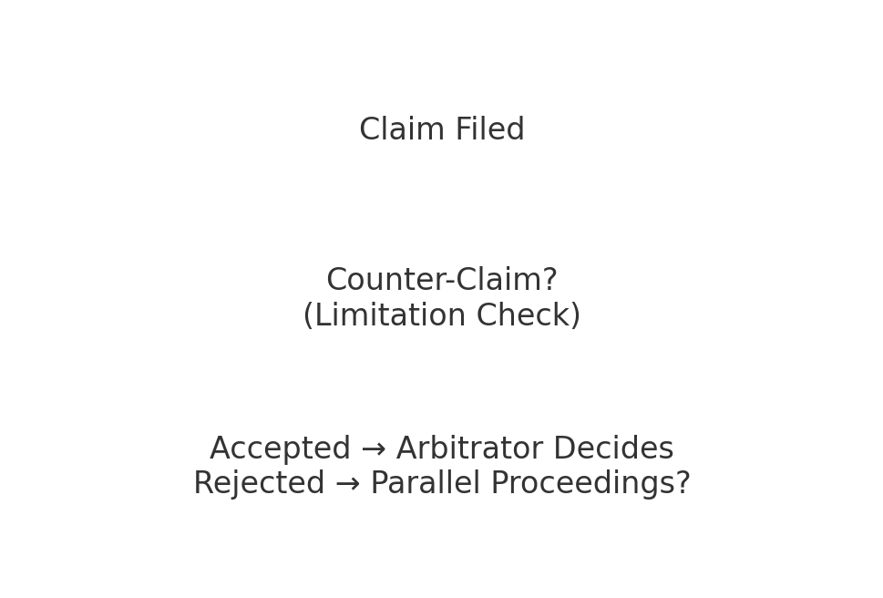

  - Introduction
Counter-claims and set-offs play an important role in ensuring that arbitral proceedings resolve all interconnected disputes in one forum. However, questions often arise regarding the limitation period for filing counter-claims, particularly when the main claim is already pending. Additionally, when an arbitral tribunal rejects a counter-claim, either on limitation or jurisdictional grounds parties, may attempt to approach other forums, potentially leading to parallel proceedings. This article examines these two key issues under Indian arbitration law.
  - Limitation for Filing Counter-Claims
Under the Limitation Act 1963, a counter-claim must be filed within the same limitation period as an independent claim. The Supreme Court in State of Goa v Praveen Enterprises (2012) clarified that counter-claims are permissible if they are within limitation on the date they are filed. Importantly, the Court held that counter-claims do not automatically relate back to the filing date of the main claim. This means that even if arbitration is timely commenced, a respondent’s counter-claim may still be rejected if the limitation period expired before filing.
Further, in Voltas Ltd v Rolta India Ltd (2014), the Bombay High Court emphasised that tribunals must independently examine the limitation period applicable to each counter-claim. Therefore, respondents should file counter-claims at the earliest opportunity to avoid dismissal on technical grounds.
  - Rejection of Counter-Claim or Set Off: Risk of Parallel Proceedings
A more complex issue arises when a tribunal rejects a counter-claim or set-off, whether due to limitation, lack of jurisdiction, or procedural grounds. Can the respondent then pursue the same claim in a civil court or another forum? Indian jurisprudence suggests that this is possible in certain circumstances.
If a counter-claim is rejected for reasons not going to the merits such as limitation, lack of jurisdiction, or procedural bar the dismissal does not operate as res judicata. This was recognised in Indian Oil Corporation Ltd v SPS Engineering (2011), where the Supreme Court noted that dismissal of a claim on technical grounds does not prevent the claimant from approaching a competent forum subsequently.
However, permitting parallel proceedings risks duplication, inconsistent findings, and increased costs. Therefore, courts often examine whether the arbitration agreement mandates exclusive resolution of “all disputes,” in which case even rejected counter-claims may fall within arbitral jurisdiction.
  - Analysis and Practical Implications
For litigators, the key takeaway is that counter-claims should be filed promptly, ideally along with or immediately after the statement of defence. Delay increases the risk of dismissal on limitation grounds. Respondents must also be aware that rejection of a counter-claim does not necessarily extinguish their substantive rights; however, initiating fresh proceedings may introduce challenges, including jurisdictional objections and efficiency concerns. Furthermore, this topic highlights the doctrinal balance between procedural fairness, party autonomy, and the need to avoid multiplicity of proceedings. Understanding the distinction between dismissal on merits and dismissal on technical grounds is crucial to predicting outcomes.
  - Conclusion
Counter-claims in arbitration demand careful attention to limitation and procedural compliance. While rejection of a counter-claim may permit parties to seek relief from other forums, this may also give rise to fragmented litigation. Clarity in drafting arbitration clauses and proactive filing of counter-claims remain the most effective safeguards against such complications.
WIELDING THE SWORD OF DAMOCLES: ARBITRAL TRIBUNAL'S POWER TO TERMINATE PROCEEDINGS FOR NON-PAYMENT OF FEES
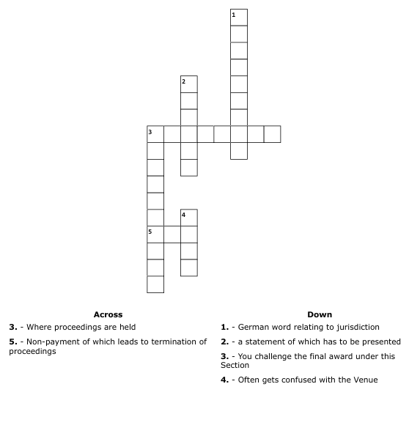
- Introduction
The power of an Arbitral Tribunal to manage its proceedings, including the collection of fees, is fundamentally rooted in the Arbitration and Conciliation Act, 1996 (A&C Act). Section 38 mandates the deposit of advance costs, covering both the Tribunal's fees and the administrative expenses. Critically, the statutory authority for termination is embedded under Section 38(2), which provides that if the required deposits are not paid within the specified period, the Arbitral Tribunal may suspend or terminate the proceedings. This discretionary power protects the integrity of the process and ensures that the arbitrators are compensated for their work.
- Analysis of Case laws
The recent Bombay High Court ruling in 22Light through its Sole Proprietor Baljit Harbans Kohli Vs. OESPL Private Limited affirmed the inherent power of an Arbitral Tribunal to terminate arbitral proceedings in their entirety upon the non-payment of advanced costs and fees by a party, as stipulated under Section 38(2) of the Arbitration and Conciliation Act, 1996 (A&C Act). ​The core legal debate stresses emphasis on whether the Tribunal could only suspend the proceedings or if it had the power to terminate them permanently, particularly when the non-payment related to the claim itself.
The High Court decisively upheld the Tribunal's power to order an outright termination, rejecting the argument that a non-defaulting party should be forced to pay the defaulting party's share to keep the arbitration alive. While the Court confirmed that the use of the word “may” in Section 38(2) grants the Arbitral Tribunal the discretion to choose between suspension and termination. This discretion must, of course, be exercised judiciously and reasonably. If exercised, then the termination is absolute, ending the proceedings since termination under Section 38(2) simultaneously results in the deemed termination of the mandate of the Tribunal under Section 32(2)(c) of the A&C Act. A distinction was also drawn from Section 25(a), which in turn terminates the proceedings for the failure of prosecuting the claim. The grounded rationale behind out-right termination is indeed essential to prevent a party from derailing the arbitration process by simply refusing to fund its share of the advance costs; since if only suspension were allowed, the process could remain indefinitely stalled
However, the Arbitrator's order terminating the proceedings is sustainable only to the extent that the facts of the case do not attract the principles laid down by the Supreme Court in Oil and Natural Gas Corporation Ltd. vs. Afcons Gunanusa JV.
The foregoing judgment places a crucial check on the arbitrary exercise of fee fixation, thereby mitigating the risk of fee-based termination. It was unequivocally clarified by the Supreme Court that where the arbitration agreement or the reference is silent on the quantum of fees, the arbitrator is generally constrained by the fee schedule specified in the Fourth Schedule of the A&C Act. Further, the Tribunal cannot unilaterally fix an ad valorem fee structure that is exorbitant or deviates significantly from the statutory schedule, as this often leads to a party’s non-payment and subsequent termination of the mandate. The Court’s ruling acts as a supervisory measure, ensuring that the power to demand fees and subsequently terminate proceedings is exercised reasonably.
- Conclusion
Ultimately, the Arbitral Tribunal's discretionary power to terminate proceedings under Section 38(2) acts as a necessary procedural enforcement tool. Juxtaposed to the wielding of this discretionary power, prevails the words of caution pronounced in Oil and Natural Gas Corporation Ltd. vs. Afcons Gunanusa JV, which precisely outlines the exercise of arbitrator’s powers within the confines of law, preventing the right to access justice from being frustrated by excessive costs.
SCOPE OF REFERENCE UNDER SECTION 11 ONLY DETERMINES PRIMA FACIE VALIDITY OF ARBITRATION AGREEMENT OR DOES IT GO BEYOND

- Scope of Judicial Review: Defining the Prima Facie Rule
Section 11 of the Arbitration and Conciliation Act, 1996 deals with the appointment of arbitrators when parties fail to reach consensus. Over the years, Indian courts have struggled to define how much scrutiny is permissible at this “referral stage.” The Supreme Court’s decision in SBI General Insurance Co. Ltd. v. Krish Spinning has now provided much-needed clarity by firmly limiting judicial interference and reinforcing the principle that arbitration should remain largely free from court intervention at the threshold.
In SBI General Insurance, the dispute arose from an insurance claim relating to fire damage, which was followed by a settlement between the parties. When arbitration was later invoked, the insurer argued that the dispute stood resolved due to “accord and satisfaction” and was therefore not arbitrable. The Supreme Court was called upon to decide whether such objections could be examined by courts while deciding an application under Section 11(6). The Court held that at this stage, the court’s role is narrow and confined only to checking whether an arbitration agreement exists on a prima facie basis.
- Arbitral Autonomy vs. Referral Courts: Distinguishing Fact from Existence
The Court clarified that issues such as accord and satisfaction, limitation of claims, or allegations of frivolity involve disputed questions of fact and law. These matters fall squarely within the jurisdiction of the arbitral tribunal and not the referral court. Allowing courts to decide such issues at the Section 11 stage would effectively amount to a premature examination of the merits, which goes against the spirit of modern arbitration law and the doctrine of competence-competence.
This reasoning aligns with the earlier decision in Vidya Drolia v. Durga Trading Corporation, where the Supreme Court held that judicial interference at the referral stage must be exercised sparingly. While Vidya Drolia permitted courts to refuse reference in rare cases where non-arbitrability is evident on the face of the record, it emphasised that such power should be used only to eliminate plainly untenable cases. SBI General Insurance narrows this window further by cautioning against judicial examination of contested facts even under the guise of arbitrability.
- Evolving Jurisprudence: Moving Away from the "Eye of the Needle" Test
The judgment also implicitly distances itself from the approach adopted in NTPC Ltd. v. SPML Infra Ltd., where the Court had introduced the “eye of the needle” test, allowing courts to reject claims that appeared ex-facie meritless or non-arbitrable. In SBI General Insurance, the Supreme Court noted that such tests risk drawing courts into factual evaluation, which defeats the efficiency of arbitration and undermines party autonomy.
At the same time, the Court preserved a limited exception recognised in Magic Eye Developers v. Green Edge Infrastructure Pvt. Ltd., where it was held that disputes concerning the very existence or validity of the arbitration agreement must be conclusively decided by the referral court. Since such issues go to the root of arbitral jurisdiction, they cannot be left to the tribunal. Beyond this narrow inquiry, however, courts must refrain from further scrutiny.
In conclusion, SBI General Insurance v. Krish Spinning marks a decisive step toward judicial restraint under Section 11. By limiting court intervention to a prima facie examination of the arbitration agreement, the Supreme Court has strengthened arbitral autonomy, reduced procedural delays, and reaffirmed India’s commitment to arbitration-friendly jurisprudence.

ALLEGATIONS OF FRAUD DO NOT AUTOMATICALLY RENDER A DISPUTE NON-ARBITRABLE; A DISTINCTION EXISTS BETWEEN SERIOUS FRAUD AND FRAUD SIMPLICITER

- The Evolution of Judicial Thinking on Fraud
The arbitrability of disputes involving allegations of fraud has long posed conceptual and practical challenges within Indian arbitration law. Traditionally, courts were hesitant to permit arbitration where fraud was alleged, primarily on the assumption that such disputes involved complex factual inquiries and elements of public wrongdoing. However, judicial thinking has evolved significantly over the past decade. The prevailing legal position today is that allegations of fraud do not, by themselves, render a dispute non-arbitrable. A clear distinction is now drawn between serious fraud that undermines the foundation of the arbitration agreement and fraud simpliciter that arises incidentally in private contractual disputes.
The foundational framework for determining arbitrability was laid down by the Supreme Court in Booz Allen and Hamilton Inc. v. SBI Home Finance Ltd. (2011). The Court classified disputes based on whether they concern rights in rem or rights in personam. While disputes affecting rights in rem such as insolvency or criminal liability were held to be non-arbitrable due to their public character, disputes involving private rights between parties were considered suitable for arbitration. Importantly, the Court clarified that merely because a dispute involves statutory or serious consequences does not automatically exclude it from arbitration unless it affects the public at large. This distinction laid the groundwork for reassessing the treatment of fraud-related disputes.
- Distinguishing Serious Fraud from Fraud Simpliciter
The Supreme Court directly addressed the arbitrability of fraud in A. Ayyasamy v. A. Paramasivam (2016). In this case, the Court departed from earlier rigid approaches and introduced a nuanced test based on the nature and gravity of the fraud alleged. It held that mere allegations of fraud simpliciter such as misrepresentation, breach of trust, or false statements made between contracting parties do not bar arbitration. Such disputes, essentially involve civil consequences and can be adequately adjudicated by arbitral tribunals. However, the Court carved out an exception for cases involving serious allegations of fraud, particularly where the fraud is so pervasive that it vitiates the entire contract, including the arbitration clause, or where the allegations resemble criminal misconduct requiring adjudication in the public domain.
The distinction drawn in Ayyasamy reflects a functional understanding of arbitration. The Court acknowledged that arbitral tribunals are capable of examining evidence, evaluating witness testimony, and resolving complex factual disputes. Therefore, the earlier assumption that fraud-related disputes necessarily require judicial determination was held to be outdated. What remains crucial is whether the fraud alleged strikes at the validity of the arbitration agreement itself or raises issues that transcend private rights and implicate public interest.
- Consolidation of the Pro-Arbitration Regime
This refined approach was further consolidated in Vidya Drolia v. Durga Trading Corporation (2021), where the Supreme Court undertook a comprehensive analysis of arbitrability. The Court reaffirmed that fraud is arbitrable when it pertains to civil disputes between parties and does not nullify the arbitration agreement. It emphasized that courts at the referral stage should confine themselves to a prima facie examination and avoid a detailed inquiry into allegations of fraud. Only in exceptional circumstances where the dispute is non-arbitrable by its very nature courts should decline reference to arbitration. This judgment reinforced the principle of kompetenz-kompetenz, allowing arbitral tribunals to rule on their own jurisdiction, including questions of arbitrability.
Collectively, these decisions signal a decisive shift towards a pro-arbitration regime. The current legal position recognizes that arbitration is not incompatible with allegations of fraud, provided such allegations do not involve serious criminal wrongdoing or invalidate the arbitration agreement itself. By distinguishing between serious fraud and fraud simpliciter, Indian courts have balanced the need to protect public interest with the autonomy of parties to resolve private disputes through arbitration.
In conclusion, allegations of fraud no longer operate as an automatic bar to arbitration in India. The emphasis has shifted from the mere presence of fraud to its nature, scope, and impact on the arbitration agreement. This evolution strengthens arbitration as an effective dispute resolution mechanism while preserving judicial oversight in cases involving grave public consequences.

JUDICIAL CLARIFICATION ON INSUFFICIENT STAMPING: AFFIRMING CURABILITY IN ARBITRATION AGREEMENT
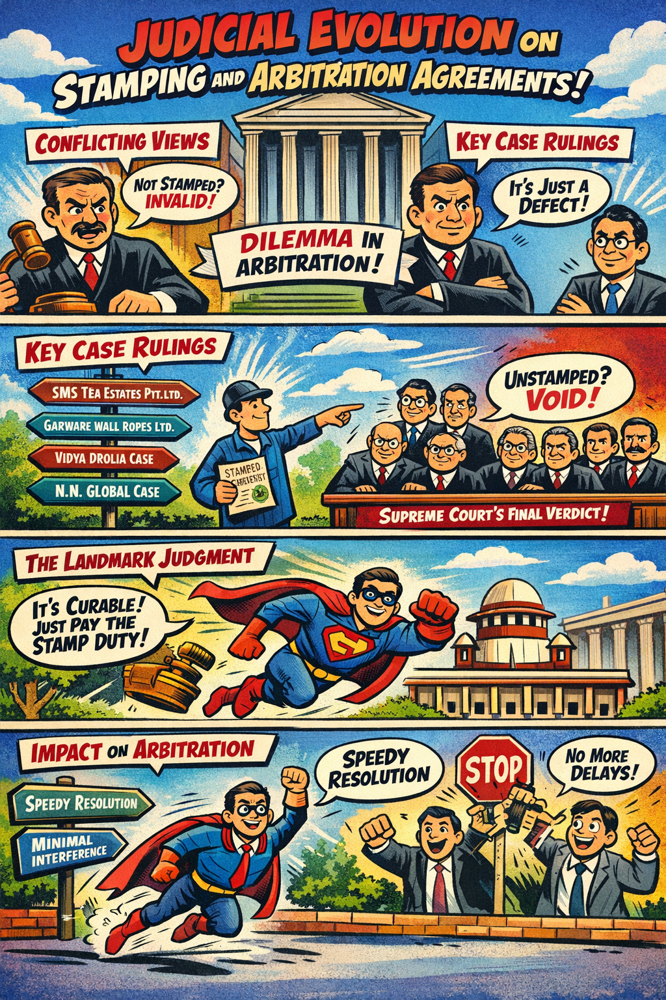
- Introduction
Stamp duty plays a significant role in determining the admissibility of documents under Indian law. For several years, courts grappled with a crucial question: does the absence or insufficiency of stamp duty invalidate an arbitration agreement, or is it merely a procedural lapse capable of correction?
This issue became particularly contentious in arbitration jurisprudence, where speed, efficiency, and minimal court interference are foundational principles. Conflicting Supreme Court decisions created uncertainty, often allowing technical objections on stamping to derail arbitration at the threshold stage.
The recent seven-judge bench ruling has finally settled the law by clarifying the nature of stamping defects and restoring coherence to arbitration practice in India.
- Judicial Evolution on Stamping and Arbitration Agreements
The jurisprudential journey began with SMS Tea Estates Private Limited v. Chandmari Tea Company Private Limited, where the Supreme Court held that courts could examine stamp duty compliance at the pre-referral stage and decline to act upon an unstamped arbitration agreement.
This approach was reinforced in Garware Wall Ropes Limited v. Coastal Marine Construction and Engineering Limited, which treated an unstamped arbitration agreement as legally non-existent until the defect was cured.
Subsequently, a nuanced view emerged in Vidya Drolia and Others v. Durga Trading Corporation, where the Court linked the “existence” of an arbitration agreement to its legal validity, including compliance with mandatory statutory requirements such as stamping. However, a departure from this restrictive interpretation was seen in N. N. Global Mercantile Private Limited v. Indo Unique Flame Limited (Three-Judge Bench), which recognised the autonomy and separability of arbitration agreements from the underlying contract.
The conflict culminated in N. N. Global Mercantile Private Limited v. Indo Unique Flame Limited (Five-Judge Bench), where a majority held that an unstamped agreement was void and unenforceable. This decision attracted criticism for expanding judicial intervention and obstructing arbitration at the threshold stage.
- Insufficiency of Stamp Duty as a Curable Defect
The controversy was conclusively settled by the seven-judge Constitution Bench in In Re: The Interplay Between Arbitration Agreements under the Arbitration and Conciliation Act, 1996 and the Indian Stamp Act, 1899.
The Court drew a critical distinction between “voidness” and “inadmissibility,” holding that Section 35 of the Stamp Act affects only the admissibility of a document in evidence and not its validity or enforceability. Since the Stamp Act itself provides a statutory mechanism for curing defects through payment of duty and penalty, insufficient stamping was held to be a curable defect. A defect capable of rectification, the Court reasoned, cannot invalidate an arbitration agreement.
- Impact and Conclusion
The decision reinforces core arbitration principles such as separability, kompetenz-kompetenz, and minimal judicial interference. Courts exercising jurisdiction under Sections 8 and 11 of the Arbitration and Conciliation Act, 1996 are now restricted to examining the prima facie existence of an arbitration agreement. Issues relating to stamp duty are to be decided by the arbitral tribunal under Section 16, which retains the power to impound the document if necessary. This interpretation ensures that technical objections do not frustrate arbitration proceedings and aligns Indian arbitration law with international best practices, as further reflected in pro-arbitration rulings such as Cox and Kings Limited v. SAP India Private Limited.
By recognising insufficiency of stamp duty as a curable procedural defect, the Supreme Court has restored certainty and efficiency to Indian arbitration law. The judgment balances revenue considerations with the fundamental objective of arbitration, i.e. speedy and effective dispute resolution, thereby strengthening India’s position as an arbitration-friendly jurisdiction.

Organizing Committee:
ARBITRATION
Mr. Gautam T. Mehta
Mr. Bhavesh V. Panjuani
Mr. Janak Dwarkadas
Mr. Anant Shende
Mr. Prashant Popat
Mr. Rakesh B. Mandavkar
Mr. Kirti G. Munshi
Mr. Raj Panchmatia
Mr. Naushad Engineer
Mr. Shikhil Suri
Mr. Satyan Israni
Mr. Vyom D. Shah
Ms. Sneha Phene
Mr. Rishi Kumar Dugar

(Please send in your entries to legal@imcnet.org.)
***********************************
Note from the editorial: Credits to all the members for encouraging and offering suggestions for this bulletin. Thank you for making this possible. Though the issue is being circulated in May 2025, we have covered recent developments from previous months.
Committee Members for Bulletin:
Mr. Prashant Popat
Ms. Sneha Phene
Mr. Rishi Kumar Dugar

2024 INSC 292
AIR 2002 SC 1771
2015 (3) SCC 49
(2019) 15 SCC 131
(2021) 2 SCC 1
Transcore v. Union of India, (2008) 1 SCC 125
A. Ayyasamy v. A. Paramasivam, (2016) 10 SCC 386
(2024) 6 SCC 1
2025 SCC OnLine SC 1699
Arbitration and Conciliation Act 1996, s 7
M.R. Engineers & Contractors Pvt Ltd v Som Datt Builders Ltd (2009) 7 SCC 696
Inox Wind Ltd v Thermocables Ltd (2018) 2 SCC 519
Bharat Broadband Network Ltd v United Telecoms Ltd (2019) 5 SCC 755
DLF Home Developers Ltd v Rajapura Homes Pvt Ltd (2021) 15 SCC 692
(2012) 12 SCC 581
AIR 2014 SC 1772
(2011) 3 SCC 507
Commercial Arb. Appl. No. 215 of 2021 (High Court Judicature at Bombay)
(2024) 4 SCC 481
2024 SCC OnLine SC 1754.
2020 SCCOnLine SC 1018.
(2023) 9 SCC 385
(2023) 8 SCC 50
2011 5 SCC 532.
AIR 2016 SC 4675
2020 SCCOnLine SC 1018.
(2011) 14 SCC 66
AIR 2019 SC 2053
2020 SCCOnLine SC 1018.
(2021) 4 SCC 379
(2023) 7 SCC 1
2023 INSC 1066
2023 SCC OnLine SC 1634

